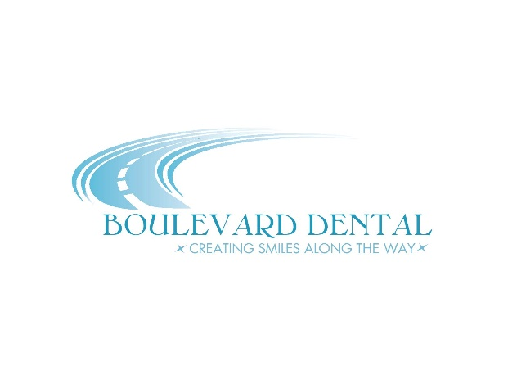
Terms and Conditions:
- Discounts provided only through Boulevard Dental and performed by Dr. Melissa Brown, D.D.S.
- Monthly membership fees are to be paid for a minimum twelve (12) month period and are non-refundable. Unless waived by the dentist, membership will automatically renew on the anniversary date and continue thereafter until cancelled, in writing.
- Qualified dependents are defined as any non-married children living in the household under 23. Any additional dependents after three (3) each will have an additional surcharge of $10 per month per dependent.
- There is a 60 day waiting period for basic and major restorative procedures.
- Fees and plan discounts are subject to change without notice.
- Missed or broken appointments without 24-hour notice will be charged $50 and anything over one hour, may be subject to additional charges.
- All member co-payments are due prior to procedure start time.
- Membership in Boulevard Dental Advantage may be terminated for abuse and failure to pay membership fees or properly billed work.
- Boulevard Dental Advantage is administered solely by the dental office and may be discontinued at the end of any month with or without notice.
Plan Limitations and Exclusions:
- Covered prophylaxis is limited to two times per calendar year. A difficult prophylaxis (i.e. heavy smoker, neglected teeth, etc.) is subject to a reasonable surcharge.
- Fluoride treatments are limited to two times per calendar year, per member, up to age of 19.
- Replacements are only eligible if the prosthetic is deemed un-restorable by dental standards, over five (5) years old, and dental prophylaxis and periodic exam appointments are kept at two (2) times per calendar year.
- Dental procedures in progress, or performed before or after a member’s eligibility period is excluded.
- Any dental procedure not listed as a covered service, including but not limited to, anesthesia, prescription medications, etc., is excluded.
- Treatment required due to hospital and medical charges or self-inflicted wounds of any kind is excluded.
- Treatment to correct congenital, developmental, or medically induced dental disorders is excluded (i.e., TMJ).
- Replacement for lost or stolen appliances is excluded unless additional insurance is purchased.
- Any dental services provided to the member by state, county, or municipal agencies, or dental services provided without cost to the member are excluded.
- Any dental expense incurred if the dentist is unable to perform a procedure due to the member’s general health or physical condition is excluded.
- Coordination of plan benefits with other plans is excluded.

A BENEFIT PLAN CREATED WITH OUR UNINSURED PATIENTS IN MIND!

Boulevard Dental
11661 College Blvd
Suite #101
Overland Park, KS 66210
Phone: 913-242-8199
www.BoulevardDental.com

BOULEVARD DENTAL ADVANTAGE
A BENEFIT PLAN OFFERED BY THE OFFICE OF MELISSA BROWN, D.D.S.

BOULEVARD DENTAL ADVANTAGE
A BENEFIT PLAN CREATED WITH OUR UNINSURED PATIENTS IN MIND!
After many years of seeing traditional dental insurance increase in price and lower in the amount of coverage, BOULEVARD DENTAL has created a cost effective solution. We offer an in-house benefit plan that allows families to keep up with routine oral hygiene visits with the added assurance that you are covered if any other dental necessity arises.
For a low monthly fee, you receive your “Preventative Care” at no cost, and any “Basic” or “Major Restorative Care” significantly discounted.

Boulevard Dental Advantage
Benefit Features**
PREVENTATIVE CARE
Oral Exams 100%
Oral Cancer Screenings 100%
Oral Hygiene Instruction 100%
Dental Cleaning (2 per year) 100%
Bitewing x-rays 100%
Periapical x-rays 100%
Full mouth x-rays (1 per 5 years) 100%
Fluoride treatment (2 per year) 100%

BASIC RESTORATIVE CARE
Fillings 80%
Extractions 40%
Sealants 80%

MAJOR RESTORATIVE CARE

Periodontal Services 50%
Endodontic Services 40%
Crown & Bridge Services 40%
Denture & Partial Services 25%
Implant Services 25%
**$10 copay applies to all visits
Monthly Fees**
- Individual $39
- Individual & Spouse $49
- Family (up to 3 dependents) $59*
*additional dependents $10
TOTAL $
Name:
Spouse/Dependents:
Address:
Phone:
Method of Payment:
- Automatic withdrawal
- Credit Card
Card type Expiration v-code
Number

Signature
Date
**$100 initial administration fee if 12 months not paid in full.

